GLMM analysis for: State of knowledge on bats’ contribution to agricultural pest suppression and interventions to support them: a global survey of researchers

Socio-economic indices being explored:
- GDP
- National R&D Investment (all sectors)
- Agricultural Economy Dependence (% of GDP from Agriculture, Forestry and Fisheries)
- Agricultural R&D Investment
- Environmental Performance Index

Accessing these datasets:
- Extracted from World Bank.org directly in R using library(WDI):
  - GDP: indicator = "NY.GDP.PCAP.CD"
  - National R&D Investment (all sectors): indicator = "GB.XPD.RSDV.GD.ZS"
  - Agricultural Economy Dependence (% of GDP from Agriculture, Forestry and Fisheries): indicator = "NV.AGR.TOTL.ZS"
- Extracted from ‘Grape’ dataset: https://www.nature.com/articles/s41597-025-05331-y?utm_source=researchgate.net&utm_medium=article#Sec10 and https://zenodo.org/records/15507361
  - Agricultural R&D Investment
- Downloaded from https://epi.yale.edu/downloads :
  - Environmental Performance Index

Bat Species Richness
- Also included in models as we hypothesised that it may be harder to gain knowledge about bats role in agricultural system if there is very high bat diversity.
- Data access: Bat species lists initially downloaded for each country from batnames.org, but cross-checked against mammaldiversity.org and iucn to filter out extinct species on the batnames.org list.

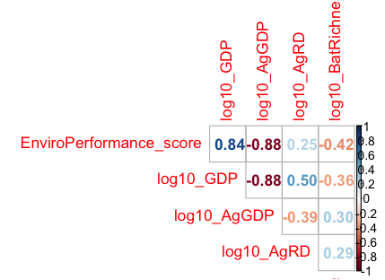
Correlation among predictors:
These are the only 'safe' combinations (less than 0.6):
- Env Performance and All R&D
- Env Performance and Ag R&D
- GDP and Ag R&D
- All R&D and Ag R&D
- Ag contribution to GDP and All R&D
- BatRichness with all others

But, we can only afford 2 predictors anyway, so unless bat spp richness is not important, then including more than one socio-economic index may result in overfitting.

Model variables and structure:
Random effects:
- (1 | Country) - This accounts for multiple respondents per country sharing the same GDP/Env Performance etc value.
- (1 | Respondent) - This accounts for multiple responses per person.
Fixed effects:
We have responses from 24 countries, and the socio-economic and bat species richness data will be at country level. Therefore, we can only ‘afford’ 2 predictors following the 10 observations per predictor rule (excluding random effects). We should prioritise finding the ‘best’ socio-economic predictor and considering how bat species richness may affect ability to gain knowledge.
- BatRichness (at country level)
- 1 of the socio-economic indices: GDP, Env Performance, Ag R&D, Ag economy dependence
Error family:
- Cannot be linear/gaussian because it assumes the value/scores can be anything. But our scores for both surveys (individual scores at each step, and average across all steps) are always between 0 and 3.
- Beta is used when outcomes/scores are bounded between two known limits (0 and 3 in our case). We can use a beta regression model if we rescale our scores to be between 0 and 1 (change back for viewing model predictions after).

Therefore, our basic model structure is:
S1_null_glmmTMB <- glmmTMB(
Rescaled mean score for Survey 1 ~ Best socio-economic index +
log10(BatRichness) +
(1|Country.clean) + (1|Respondent.clean),
family = beta_family(), data = Survey_1_complete)

We can run alternative models with each of the socio-economic indices for both surveys in two ways:
- Where the response variable is the mean score for Survey 1 (mean across all steps in the knowledge pathway) and Survey 2 (mean across all interventions), or
- Run separate models for each step in the knowledge pathway (Survey 1), or each specific intervention (Survey 2). E.g.:
S2_revegetation_EP <- glmmTMB(Rescaled Survey 2 scores for revegetation ~ EnviroPerformance_score + log10(BatRichness) + (1 | Country.clean), family = beta_family(), data = d_revegetation)

Also compare to null models with this structure:
S1_null_glmmTMB <- glmmTMB(
Rescaled score ~ 1 +
(1|Country.clean) + (1|Respondent.clean),
family = beta_family(), data = dat)

Models within 2 AICc’s of each other are comparable. And if the null model is comparable to others with predictors, then those predictors do not have strong support...

Model comparisons

1a. Survey 1 – Response variable = mean score across knowledge pathway
model | AICc | delta_AICc | AICc_weight | meaningful_support
EP | -42.512391 | 0 | 0.30445842 | TRUE
EP_BatRichness | -41.857439 | 0.65495179 | 0.21943556 | TRUE
EP_AgRD | -40.165714 | 2.34667668 | 0.0941789 | FALSE
EP_AgRD_BatRichness | -40.087486 | 2.42490491 | 0.09056629 | FALSE
Ag_GDP | -39.56206 | 2.95033105 | 0.06964208 | FALSE
null | -39.091157 | 3.42123353 | 0.05503216 | FALSE
Ag_GDP_BatRichness | -37.74639 | 4.76600112 | 0.02809338 | FALSE
GDP | -37.579439 | 4.93295174 | 0.02584349 | FALSE
AgGDP_AgRD | -37.228347 | 5.28404382 | 0.02168265 | FALSE
Ag_RD | -36.931583 | 5.58080779 | 0.01869265 | FALSE
BatRichness | -36.796996 | 5.71539529 | 0.01747615 | FALSE
AgGDP_AgRD_BatRichness | -35.68031 | 6.83208133 | 0.00999909 | FALSE
EP_CropType | -35.54227 | 6.97012068 | 0.00933223 | FALSE
GDP_BatRichness | -35.421423 | 7.09096821 | 0.00878504 | FALSE
GDP_AgRD | -35.209183 | 7.30320764 | 0.00790054 | FALSE
Ag_RD_BatRichness | -34.560581 | 7.95180995 | 0.00571234 | FALSE
GDP_AgRD_BatRichness | -33.10593 | 9.40646109 | 0.0027602 | FALSE
EP_AgRD_CropType | -32.852135 | 9.66025571 | 0.00243125 | FALSE
Ag_GDP_CropType | -32.817208 | 9.69518279 | 0.00238916 | FALSE
CropType | -31.929974 | 10.5824167 | 0.00153315 | FALSE
EP_AgRD_BatRichness_CropType | -30.725419 | 11.7869718 | 0.0008395 | FALSE
Lat | -30.078766 | 12.4336245 | 0.00060758 | FALSE
AgGDP_AgRD_CropType | -30.037908 | 12.4744826 | 0.00059529 | FALSE
GDP_CropType | -29.983739 | 12.5286519 | 0.00057938 | FALSE
Ag_RD_CropType | -29.758043 | 12.7543476 | 0.00051756 | FALSE
BatRichness_CropType | -29.16833 | 13.3440613 | 0.00038539 | FALSE
Lat_BatRichness | -27.750658 | 14.7617328 | 0.0001897 | FALSE
GDP_AgRD_CropType | -27.312339 | 15.2000518 | 0.00015236 | FALSE
AgGDP_AgRD_BatRichness_CropType | -27.266228 | 15.246163 | 0.00014889 | FALSE
GDP_AgRD_BatRichness_CropType | -24.362102 | 18.1502893 | 3.4853E-05 | FALSE
Lat_CropType | -20.381132 | 22.1312591 | 4.762E-06 | FALSE

Comparison of the best models (EP and EP_BatRichness):
> anova(S1_EP_glmmTMB, S1_EP_BatRichness_glmmTMB)
Data: Survey_1_complete
Models:
S1_EP_glmmTMB: Survey_1_mean_rescaled_beta ~ EnviroPerformance_score + (1 | , zi=~0, disp=~1
S1_EP_glmmTMB: Country.clean) + (1 | Respondent.clean), zi=~0, disp=~1
S1_EP_BatRichness_glmmTMB: Survey_1_mean_rescaled_beta ~ EnviroPerformance_score + log10(BatRichness) + , zi=~0, disp=~1
S1_EP_BatRichness_glmmTMB: (1 | Country.clean) + (1 | Respondent.clean), zi=~0, disp=~1
Df AIC BIC logLik deviance Chisq Chi Df Pr(>Chisq)
S1_EP_glmmTMB 5 -43.395 -31.874 26.697 -53.395
S1_EP_BatRichness_glmmTMB 6 -43.111 -29.287 27.556 -55.111 1.7164 1 0.1902

No significant improvement in the model when BatRichness is added, therefore preference the more parsimonious (simpler) model.

Predictions for best model:
> summary(S1_EP_glmmTMB_fulldata)
Family: beta ( logit )
Formula: Survey_1_mean_rescaled_beta ~ EnviroPerformance_score + +(1 | Country.clean) + (1 | Respondent.clean)
Data: Survey_1_respondent_rescaled_beta

AIC BIC logLik -2*log(L) df.resid
-44.3 -32.7 27.2 -54.3 70

Random effects:

Conditional model:
Groups Name Variance Std.Dev.
Country.clean (Intercept) 1.861e-01 4.314e-01
Respondent.clean (Intercept) 9.218e-10 3.036e-05
Number of obs: 75, groups: Country.clean, 24; Respondent.clean, 37

Dispersion parameter for beta family (): 7.59

Conditional model:
Estimate Std. Error z value Pr(>|z|)
(Intercept) -1.374445 0.482548 -2.848 0.0044 **
EnviroPerformance_score 0.023478 0.009254 2.537 0.0112 *
---
Signif. codes: 0 ‘***’ 0.001 ‘**’ 0.01 ‘*’ 0.05 ‘.’ 0.1 ‘ ’ 1

Model prediction (black line) + raw data (points) for mean Knowledge Pathway score (across all steps) by country-level Environmental Performance scores
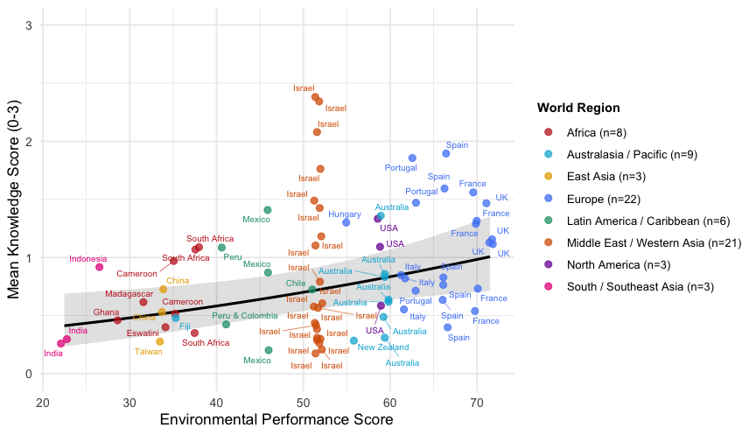

1b. Survey 1 – Response variable = score at each step in pathway (separate models for step 1,2,3, etc)
- Yet to complete, if needed

2a. Survey 2 – Response variable = mean score across all interventions
model | AICc | delta_AICc | AICc_weight | meaningful_support
EP | -84.850832 | 0 | 0.51056503 | TRUE
EP_AgRD | -82.444145 | 2.40668697 | 0.15326593 | FALSE
EP_BatRichness | -82.349757 | 2.50107506 | 0.14620072 | FALSE
Ag_GDP | -80.33577 | 4.5150624 | 0.0534094 | FALSE
EP_AgRD_BatRichness | -79.850529 | 5.00030352 | 0.04190337 | FALSE
GDP | -79.329677 | 5.52115491 | 0.03229591 | FALSE
Ag_GDP_BatRichness | -78.022738 | 6.82809368 | 0.01680155 | FALSE
GDP_BatRichness | -77.086036 | 7.76479613 | 0.01051834 | FALSE
GDP_AgRD | -76.985606 | 7.86522577 | 0.0100032 | FALSE
null | -76.908649 | 7.94218357 | 0.0096256 | FALSE
BatRichness | -75.693895 | 9.15693702 | 0.00524382 | FALSE
Ag_RD | -74.989159 | 9.86167362 | 0.00368651 | FALSE
Ag_RD_BatRichness | -74.527575 | 10.3232574 | 0.00292674 | FALSE
GDP_AgRD_BatRichness | -74.497795 | 10.3530369 | 0.00288348 | FALSE
EP_CropType | -70.605343 | 14.2454895 | 0.0004118 | FALSE
EP_AgRD_CropType | -67.385809 | 17.4650233 | 8.2332E-05 | FALSE
Ag_GDP_CropType | -65.983347 | 18.8674849 | 4.0835E-05 | FALSE
Lat | -65.632982 | 19.2178501 | 3.4273E-05 | FALSE
CropType | -65.317842 | 19.5329904 | 2.9276E-05 | FALSE
GDP_CropType | -64.929498 | 19.9213342 | 2.411E-05 | FALSE
EP_AgRD_BatRichness_CropType | -64.014861 | 20.835971 | 1.5261E-05 | FALSE
Lat_BatRichness | -63.275328 | 21.5755042 | 1.0544E-05 | FALSE
Ag_RD_CropType | -62.841875 | 22.0089576 | 8.4892E-06 | FALSE
BatRichness_CropType | -62.633215 | 22.2176172 | 7.6482E-06 | FALSE
GDP_AgRD_CropType | -61.710889 | 23.1399428 | 4.8225E-06 | FALSE
GDP_AgRD_BatRichness_CropType | -58.545385 | 26.3054474 | 9.9059E-07 | FALSE
Lat_CropType | -50.830854 | 34.019978 | 2.0927E-08 | FALSE

The model with Env Performance is best:
> summary(S2_EP_glmmTMB_fulldata)
Family: beta ( logit )
Formula: Survey_2_mean_rescaled_beta ~ EnviroPerformance_score + (1 |
Country.clean) + (1 | Respondent.clean)
Data: Survey_2_respondent_rescaled_beta

AIC BIC logLik -2*log(L) df.resid
-88.2 -77.9 49.1 -98.2 53

Random effects:

Conditional model:
Groups Name Variance Std.Dev.
Country.clean (Intercept) 2.635e-02 1.623e-01
Respondent.clean (Intercept) 5.888e-10 2.426e-05
Number of obs: 58, groups: Country.clean, 24; Respondent.clean, 36

Dispersion parameter for beta family (): 13.7

Conditional model:
Estimate Std. Error z value Pr(>|z|)
(Intercept) -2.538446 0.399042 -6.361 2e-10 ***
EnviroPerformance_score 0.024327 0.007225 3.367 0.00076 ***
---
Signif. codes: 0 ‘***’ 0.001 ‘**’ 0.01 ‘*’ 0.05 ‘.’ 0.1 ‘ ’ 1

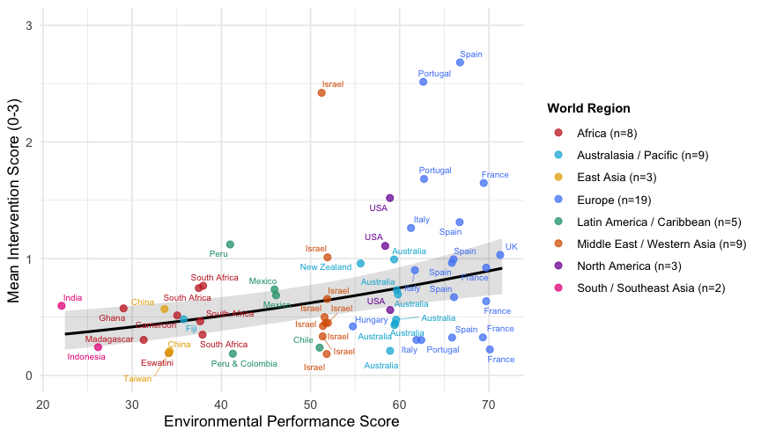

2b. Survey 2 – Response variable = score for each intervention (separate models for the level of testing of bat boxes, revegetation, bat lures etc)
Let’s fit models for each intervention with each of the socio-economic indices:

Best Artificial Roost model
The null model is best and comparable with (within 2 AICc’s better than) alternatives:
rescaled score for testing artificial roosts ~ 1 + (1|Country.clean) + (1|Respondent.clean)

Best Artificial Water model
The Latitude only model is best, but comparable to Null (within 2 AICc’s):
rescaled score for testing of water sources ~ log10(Latitude) + (1|Country.clean) + (1|Respondent.clean)

Best Acoustic Bat Lure model
The null model is best and comparable with (within 2 AICc’s better than) alternatives:
rescaled score for testing of acoustic lures ~ 1 + (1|Country.clean) + (1|Respondent.clean)

Best Bat Education model
The Latitude only model is best, but comparable to Null (within 2 AICc’s):
rescaled score for testing of bat education ~ ~ log10(Latitude) + (1|Country.clean) + (1|Respondent.clean)

Best Agrochemical Reduction model
The Environmental Performance only is best but comparable with Null (within 2 AICc’s):
rescaled score for testing of agrochemical reduction ~ Environmental Performance score + (1|Country.clean) + (1|Respondent.clean)

Best Revegetation model
The Environmental Performance only is best but comparable with Null (within 2 AICc’s): rescaled score for testing of revegetation ~ Environmental Performance score + (1|Country.clean) + (1|Respondent.clean)

